Практическая работа №8

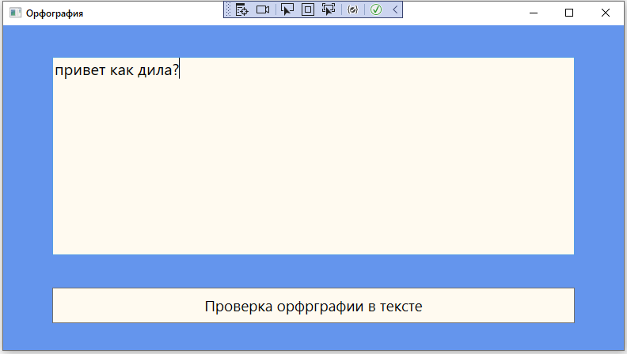

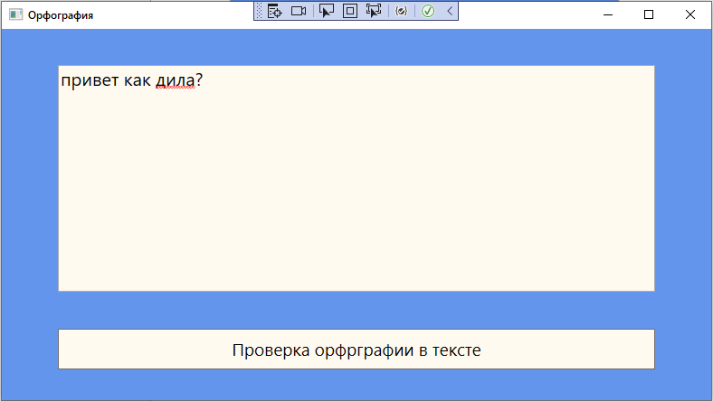

Код:

<Window x:Class="орфография.MainWindow"

xmlns="http://schemas.microsoft.com/winfx/2006/xaml/presentation"

xmlns:x="http://schemas.microsoft.com/winfx/2006/xaml"

xmlns:d="http://schemas.microsoft.com/expression/blend/2008"

xmlns:mc="http://schemas.openxmlformats.org/markup-compatibility/2006"

xmlns:local="clr-namespace:орфография"

mc:Ignorable="d"

Title="Орфография" Height="450" Width="800">

<Grid Background="CornflowerBlue">

<TextBox FontSize="20" Background="FloralWhite" Name="textbox" HorizontalAlignment="Center" Height="251" Margin="40" TextWrapping="Wrap" VerticalAlignment="Top" Width="660"/>

<Button Background="FloralWhite" Name ="button" Click ="click" Content="Проверка орфрграфии в тексте" FontSize="19" HorizontalAlignment="Center" Height="45" Margin="0,332,0,0" VerticalAlignment="Top" Width="660"/>

</Grid>

</Window>

using System;

using System.Collections.Generic;

using System.Linq;

using System.Text;

using System.Threading.Tasks;

using System.Windows;

using System.Windows.Controls;

using System.Windows.Data;

using System.Windows.Documents;

using System.Windows.Input;

using System.Windows.Media;

using System.Windows.Media.Imaging;

using System.Windows.Navigation;

using System.Windows.Shapes;

namespace орфография

{

/// <summary>

/// Логика взаимодействия для MainWindow.xaml

/// </summary>

public partial class MainWindow : Window

{

public MainWindow()

{

InitializeComponent();

}

public void click(object sender, RoutedEventArgs e)

{

textbox.SpellCheck.IsEnabled = true;

}

}

}